Weekly Environment Setup

Please follow this instruction guide to set up your in-class environment.

1. Navigate to the link provided, and download the file. This has the material that we'll be working with today!

<https://shorturl.at/knqEX>

3. Boot up Anaconda Navigator, and scroll down the list of applications to find and launch the Jupyter notebook app. 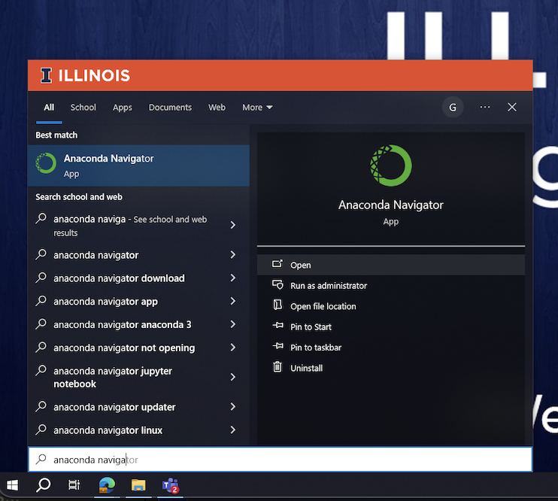

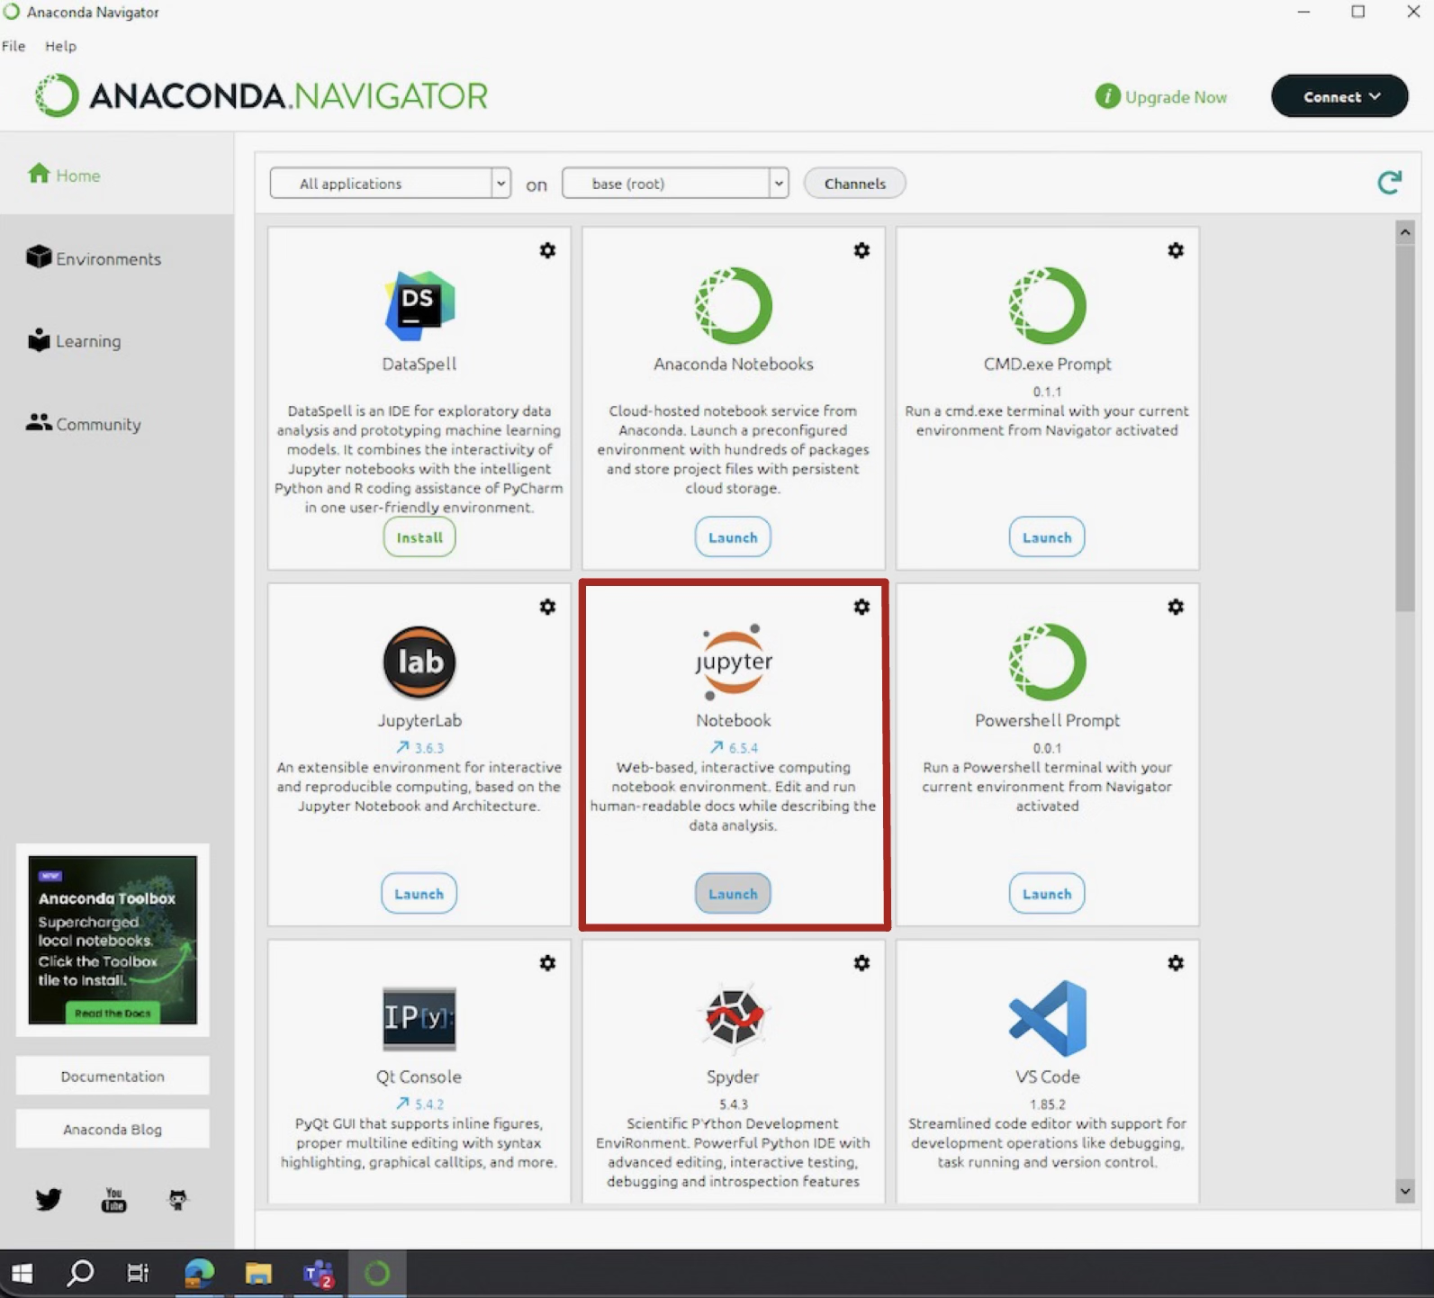

This should direct you to an online Jupyter notebook interface where you can open up class materials.

4. Navigate to your Downloads folder, where the downloaded file should be stored. Open the file and you are ready for class!

<https://uofi.box.com/s/38xk53zoa6jxi9k09ewlyh8n99c6qap5>